Exercise 1.
How to generate Discrete-Time Signals in MATLAB.

Only causal signals are generated in this exercise, i.e. signals x(n)=0 when n<0.
You can use the Matlab-commands figure, subplot and stem to plot the signals. The commands title, xlabel, and ylabel can be used to put text in the plot.
For knowing more about a command, i.e. a Matlab function, you can use the help command, e.g. by giving the command help subplot you get information about the subplot command.

The Unit Impulse signal δ(n) and the Unit Step signal u(n).
The signals should have a length of 20 samples, i.e. n=0, 1, 2, ……., 19.
Generate the following signals:
- δ(n) and δ(n-5)
- u(n) and u(n-5).
Plot the impulse signals in one figure by using subplot(2,1,1), subplot(2,1,2) and stem.
Do the same for the step signals.
Useful commands to generate these signals are zeros and ones.

Also make a pulse signal p(n), out of the difference of two step signals, defined as

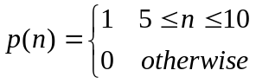

Plot the two step signals and the pulse in one figure.

The Cosine and Sine signal.
The signals should have a length of 20 samples, i.e. n=0, 1, 2, ……., 19.
Generate a cosine signal x1(n) and a sine signal x2(n)
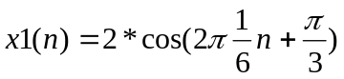
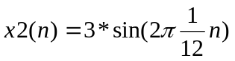.

Also generate the sum of x1(n) and x2(n).

Plot the three signals in the same plot.
Identify for each signal its amplitude, frequency, period, and phase in the plot.

The Exponential signal.
The signals should have a length of 40 samples, i.e. n=0, 1, 2, ……., 39.
The exponential signal
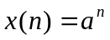
is a real signal if the parameter a is real, or a complex signal if the parameter a is complex.

Generate a real exponential signal when the parameter a is 0 < a < 1, a > 1, -1 < a < 0, and a < -1.
Plot the signals in one plot.

If the parameter 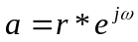 you get a complex exponential signal.
Write down the mathematical expressions for the amplitude and the phase signals and also for the real and the imaginary signals of the complex exponential.

Generate and plot the amplitude and the phase signals and also the real and the imaginary signals of the complex exponential for r=0.9 and ω=π/6.
Compare the respective plot with its mathematical expression to see if they match.

Put r=1.1 and generate and plot the signals you did before.
What is the main difference of the two exponentials when r=0.9 compared to when r=1.1?

